# Kubernetes NodePort vs LoadBalancer vs Ingress? When should I use what?

Recently, someone asked me what the difference between NodePorts, LoadBalancers, and Ingress were. They are all different ways to get external traffic into your cluster, and they all do it in different ways. Let’s take a look at how each of them work, and when you would use each.

***Note:*** *Everything here applies to* [*Google Kubernetes Engine.*](https://cloud.google.com/gke) *If you are running on another cloud, on prem, with minikube, or something else, these will be slightly different. I’m also not going into deep technical details. If you are interested in learning more, the* [*official documentation*](https://kubernetes.io/docs/concepts/services-networking/service/) *is a great resource!*

# ClusterIP

A ClusterIP service is the default Kubernetes service. It gives you a service inside your cluster that other apps inside your cluster can access. There is no external access.

The YAML for a ClusterIP service looks like this:

apiVersion: v1

kind: Service

metadata:

name: my-internal-service

spec:

selector:

app: my-app

type: ClusterIP

ports:

- name: http

port: 80

targetPort: 80

protocol: TCP

If you can’t access a ClusterIP service from the internet, why am I talking about it? Turns out you can access it using the Kubernetes proxy!



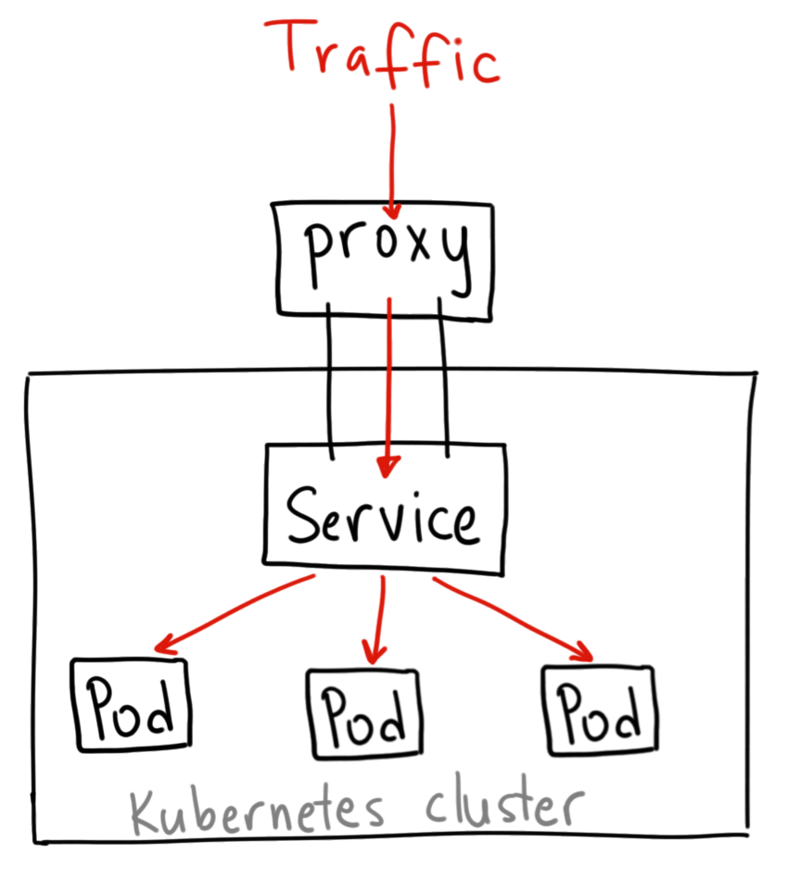

Thanks to

[Ahmet Alp Balkan](https://medium.com/u/2cac56571879?source=post_page-----922f010849e0--------------------------------)

for the diagrams

Start the Kubernetes Proxy:

$ kubectl proxy --port=8080

Now, you can navigate through the Kubernetes API to access this service using this scheme:

http://localhost:8080/api/v1/proxy/namespaces/<NAMESPACE>/services/<SERVICE-NAME>:<PORT-NAME>/

So to access the service we defined above, you could use the following address:

http://localhost:8080/api/v1/proxy/namespaces/default/services/my-internal-service:http/

## When would you use this?

There are a few scenarios where you would use the Kubernetes proxy to access your services.

1. Debugging your services, or connecting to them directly from your laptop for some reason
2. Allowing internal traffic, displaying internal dashboards, etc.

Because this method requires you to run kubectl as an authenticated user, you should NOT use this to expose your service to the internet or use it for production services.

# NodePort

A NodePort service is the most primitive way to get external traffic directly to your service. NodePort, as the name implies, opens a specific port on all the Nodes (the VMs), and any traffic that is sent to this port is forwarded to the service.



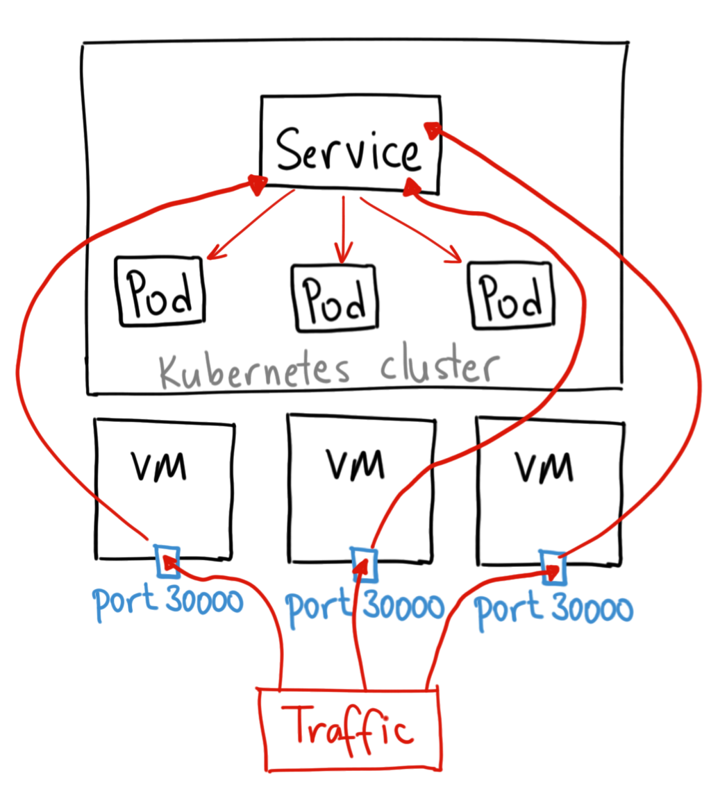

This isn’t the most technically accurate diagram, but I think it illustrates the point of how a NodePort works

The YAML for a NodePort service looks like this:

apiVersion: v1

kind: Service

metadata:

name: my-nodeport-service

spec:

selector:

app: my-app

type: NodePort

ports:

- name: http

port: 80

targetPort: 80

nodePort: 30036

protocol: TCP

Basically, a NodePort service has two differences from a normal “ClusterIP” service. First, the type is “NodePort.” There is also an additional port called the nodePort that specifies which port to open on the nodes. If you don’t specify this port, it will pick a random port. Most of the time you should let Kubernetes choose the port; as

[thockin](https://medium.com/u/d399b620658f?source=post_page-----922f010849e0--------------------------------)

says, there are many caveats to what ports are available for you to use.

To expose the NodePort to the outside worked use:

**minikube service --url <my-service>**

## When would you use this?

There are many downsides to this method:

1. You can only have one service per port
2. You can only use ports 30000–32767
3. If your Node/VM IP address change, you need to deal with that

For these reasons, I don’t recommend using this method in production to directly expose your service. If you are running a service that doesn’t have to be always available, or you are very cost sensitive, this method will work for you. A good example of such an application is a demo app or something temporary.

# LoadBalancer

A LoadBalancer service is the standard way to expose a service to the internet. On GKE, this will spin up a [Network Load Balancer](https://cloud.google.com/compute/docs/load-balancing/network/) that will give you a single IP address that will forward all traffic to your service.



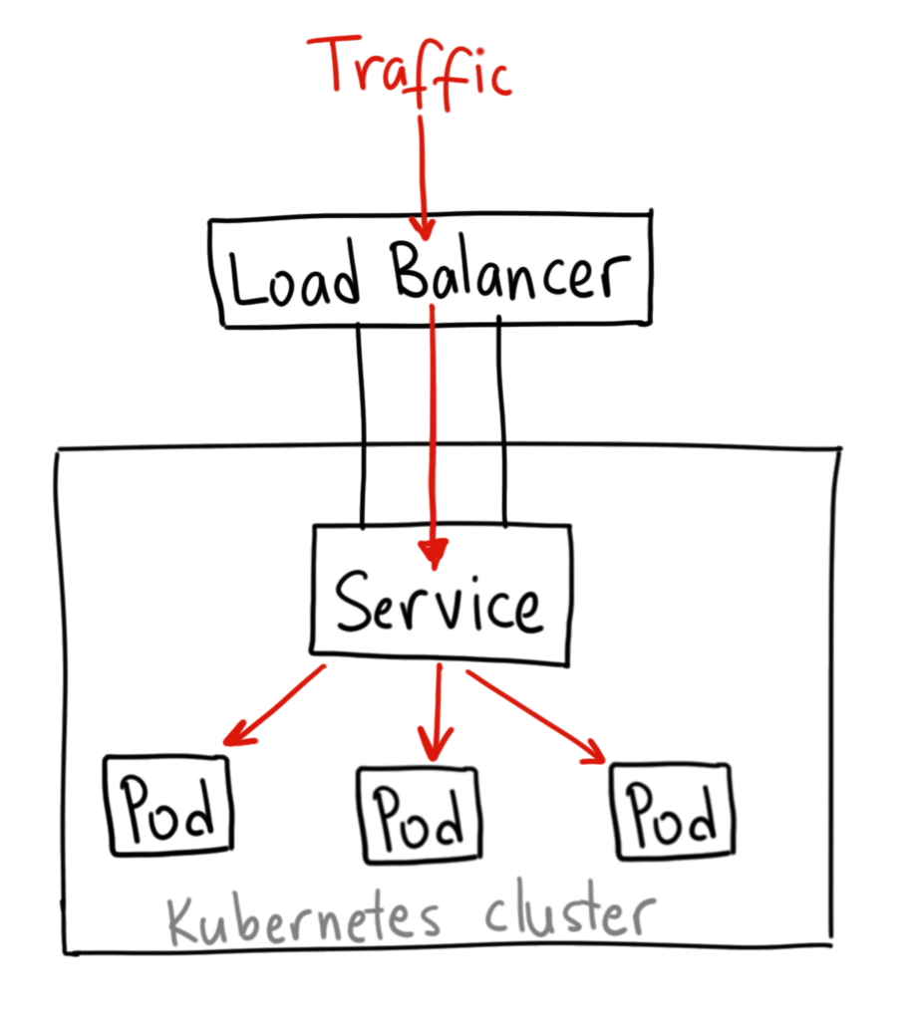

Thanks to

[Ahmet Alp Balkan](https://medium.com/u/2cac56571879?source=post_page-----922f010849e0--------------------------------)

for the diagrams

## When would you use this?

If you want to directly expose a service, this is the default method. All traffic on the port you specify will be forwarded to the service. There is no filtering, no routing, etc. This means you can send almost any kind of traffic to it, like HTTP, TCP, UDP, Websockets, gRPC, or whatever.

The big downside is that each service you expose with a LoadBalancer will get its own IP address, and you have to pay for a LoadBalancer per exposed service, which can get expensive!

# Ingress

Unlike all the above examples, Ingress is actually NOT a type of service. Instead, it sits in front of multiple services and act as a “smart router” or entrypoint into your cluster.

You can do a lot of different things with an Ingress, and there are many types of Ingress controllers that have different capabilities.

The default GKE ingress controller will spin up a [HTTP(S) Load Balancer](https://cloud.google.com/compute/docs/load-balancing/http/) for you. This will let you do both path based and subdomain based routing to backend services. For example, you can send everything on foo.yourdomain.com to the foo service, and everything under the yourdomain.com/bar/ path to the bar service.



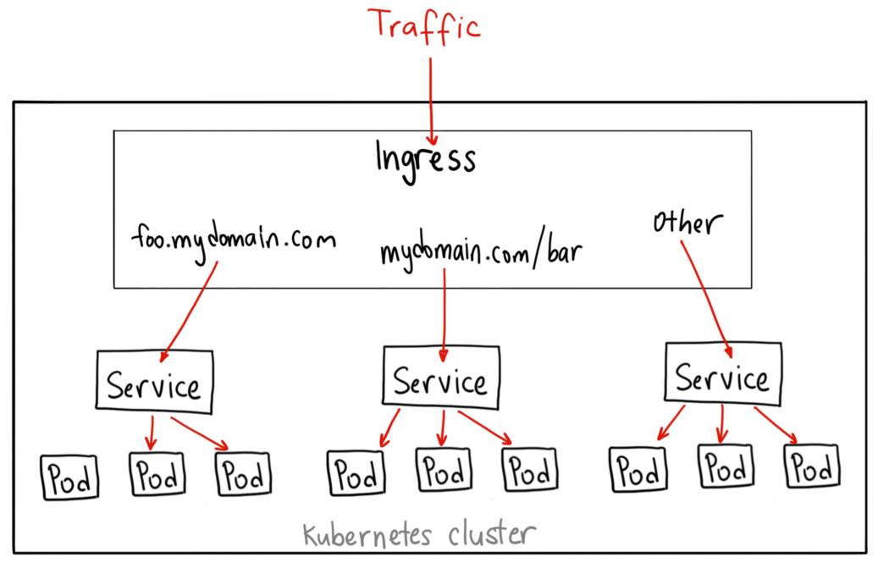

Thanks to

[Ahmet Alp Balkan](https://medium.com/u/2cac56571879?source=post_page-----922f010849e0--------------------------------)

for the diagrams

The YAML for a Ingress object on GKE with a [L7 HTTP Load Balancer](https://cloud.google.com/compute/docs/load-balancing/http/) might look like this:

apiVersion: extensions/v1beta1

kind: Ingress

metadata:

name: my-ingress

spec:

backend:

serviceName: other

servicePort: 8080

rules:

- host: foo.mydomain.com

http:

paths:

- backend:

serviceName: foo

servicePort: 8080

- host: mydomain.com

http:

paths:

- path: /bar/*

backend:

serviceName: bar

servicePort: 8080

## When would you use this?

Ingress is probably the most powerful way to expose your services, but can also be the most complicated. There are many types of Ingress controllers, from the [Google Cloud Load Balancer](https://cloud.google.com/kubernetes-engine/docs/tutorials/http-balancer), [Nginx](https://github.com/kubernetes/ingress-nginx), [Contour](https://github.com/heptio/contour), [Istio](https://istio.io/docs/tasks/traffic-management/ingress.html), and more. There are also plugins for Ingress controllers, like the [cert-manager](https://github.com/jetstack/cert-manager), that can automatically provision SSL certificates for your services.

Ingress is the most useful if you want to expose multiple services under the same IP address, and these services all use the same L7 protocol (typically HTTP). You only pay for one load balancer if you are using the native GCP integration, and because Ingress is “smart” you can get a lot of features out of the box (like SSL, Auth, Routing, etc)